Maintenance and Feeding (Nutrient) Instructions:
- Keep the lights on a timer. 12 hours on and 12 hours off is the best schedule.
- Starting the tower: Prepare your tower by mixing the fertilizer of your choice according to the instructions on the fertilizer label and fill the base/reservoir of the tower with 3-4 gallons of this nutrient and water solution. Do NOT over fertilize, read the directions on the bottle.

READ the directions, don’t over fertilize!!!!!
It’s a good idea to reduce the fertilizer on water additions after the initial starting of the
system to prevent nutrient buildup and overload.

If you are using Dyna Grow Fertilizer:
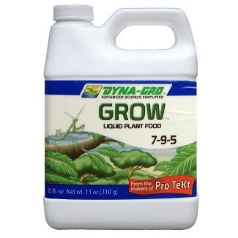
- When you add water to the tower initially, add 2-3 tsp of fertilizer per gallon.
- When you add water as the tower is going, reduce it to 1 tsp/gallon
- If you have too much algae in the water and it gets very green, replace all the water and treat it as you would as if you were starting the tower again.

- Monitor water levels and replace water, add nutrients to water before adding according to directions on container, as necessary. DO NOT let the water level go down too much or you will burn out your pump.
- Watch leaves for any browning or yellowing. This will let you know if you have enough or too much nutrient in your water. Check the pH regularly and adjust with proper solutions if necessary.

Adding New Plants to Your Tower:
- Plants should be grown on a shelf with lights at most 3” from the container they are grown in. If you don’t have a shelf, grow the plants on a plate on the top of the tower. Keep watered regularly to keep them from drying out. A spray bottle is best.
- Plants should have their second set of leaves before adding them to the tower.
- Be sure to push the cube or grow media down far enough into the elbow so that it is securely nestled in the elbow underneath the three holes that you drilled but be sure not to push them too far and lose them inside the tower.

Harvesting Your Plants
- Plants do not need to be harvested all at once. You can use the leaves as they grow.
- Pick lettuce leaves from the outside to encourage continuing growth. Do not pick from the middle of lettuce
- Herbs should be picked so that you don’t remove all the leaves. The plants will sprout new leaves.
- Always remove any flowers on herbs.

